

UNIVERSITI KUALA LUMPUR
MALAYSIAN INSTITUTE OF INFORMATION TECHNOLOGY (UniKL MIIT)
IKB42803 – INCIDENT RESPONSE AND MANAGEMENT
ASSIGNMENT 1
MALWARE THREAT TRIAGE AND INCIDENT RESPONSE ANALYSIS

Name | MUHAMMAD ASYRAF KASYFI BIN JAFRI
Student ID | 52215124469
Programme | BCSS
Tutorial/Group | L03-B01

TABLE OF CONTENTS

1.0 Executive Summary…………………………………………………………………………1
2.0 Part A: Threat Intelligence and OSINT Analysis…………………………………….1
2.1 Artifact 1 – Suspicious File Hash…………………………………………………………1
2.2 Malware Family, Category and Function………………………………………………3
2.3 Artifact 2 – Network Indicator…………………………………………………………….3
2.4 Hash and IP Correlation…………………………………………………………………….4
3.0 Part B: Windows Artifact and Malware Behaviour Analysis……………………..4
3.1 Registry Persistence…………………………………………………………………………4
3.2 Persistence Value Analysis………………………………………………………………..5
3.3 Process Execution…………………………………………………………………………….5
3.4 Network Behaviour…………………………………………………………………………...6
3.5 Malware Behaviour Correlation………………………………………………………….6
4.0 Part C: Incident Containment, Eradication and Threat Hunting…………………7
4.1 Endpoint Containment………………………………………………………………………..7
4.2 Network Containment…………………………………………………………………………7
4.3 Persistence Removal…………………………………………………………………………..8
4.4 Threat Hunting……………………………………………………………………………………8
4.5 Prioritized Incident Response Recommendation……………………………………..9
5.0Conclusion…………………………………………………………………………………………10

1.0 EXECUTIVE SUMMARY
This document covers a possible malware attack on the HR workstation in Kuala Lumpur, Malaysia. The attack began after an employee opened an email attachment which was presented as an updated Employee Benefits Form. Upon opening of the attachment, the workstation slowed down, and some strange Windows processes were spotted. The SOC then isolated the workstation to stop any further malicious actions.
The analysis will concentrate on the following points: suspicious SHA-256 hash, an attempt to establish an outbound connection to IP 193.32.232.64:7777, Registry and process activity. Threat intelligence was acquired with VirusTotal and AlienVault OTX. Windows artifact collection reveals that the malware uses a Registry Run key to ensure persistence, executes from Temp folder, and runs commands via cmd.exe with the use of a temporary batch file.
The workstation needs to be kept isolated until the investigation is finished. Then, the system should be reimaged or restored to a previously clean state. The SOC also needs to block all confirmed malicious traffic and hunt for the same IOCs on other workstations.

2.0 PART A: THREAT INTELLIGENCE AND OSINT ANALYSIS
2.1 Artifact 1 – Suspicious File Hash
SHA-256 Hash:
06417db53e9b090c7a07192dbb6203ce15c832c0928d73ebbc9c8ebff05320ff
The hash was checked using VirusTotal and AlienVault OTX. Both platforms provide threat-intelligence information without requiring the investigator to download or run the suspicious file.
VirusTotal reported a detection ratio of 59/70 (84.29%). A high detection ratio indicates that many security engines consider the file malicious. The detection names and other information from the results can also help identify the malware family.
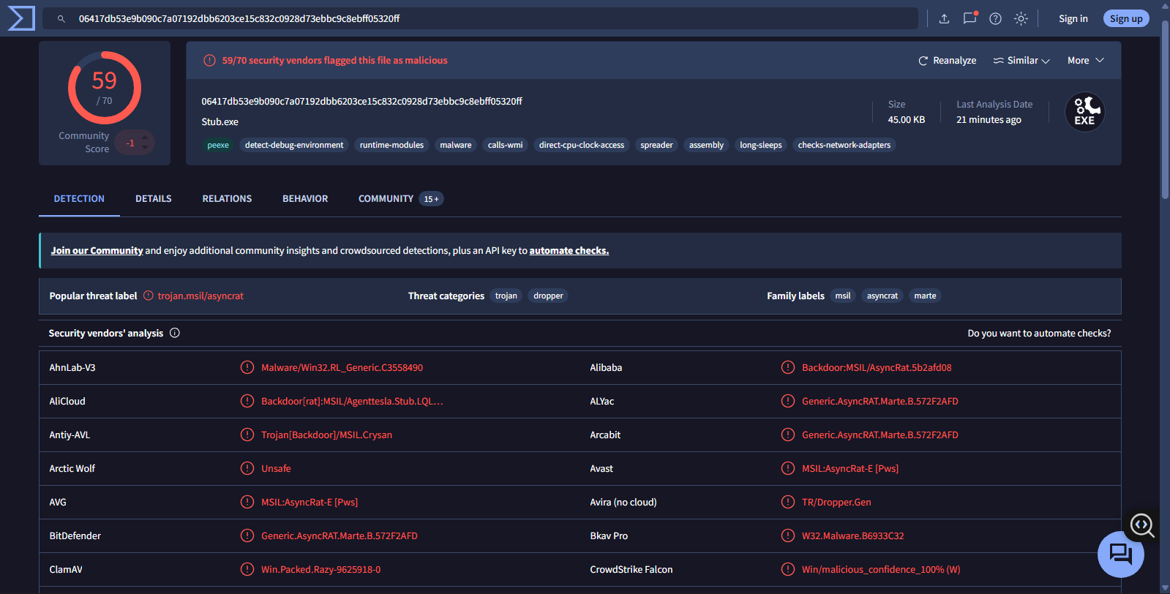
Figure 1. VirusTotal analysis of the suspicious executable.
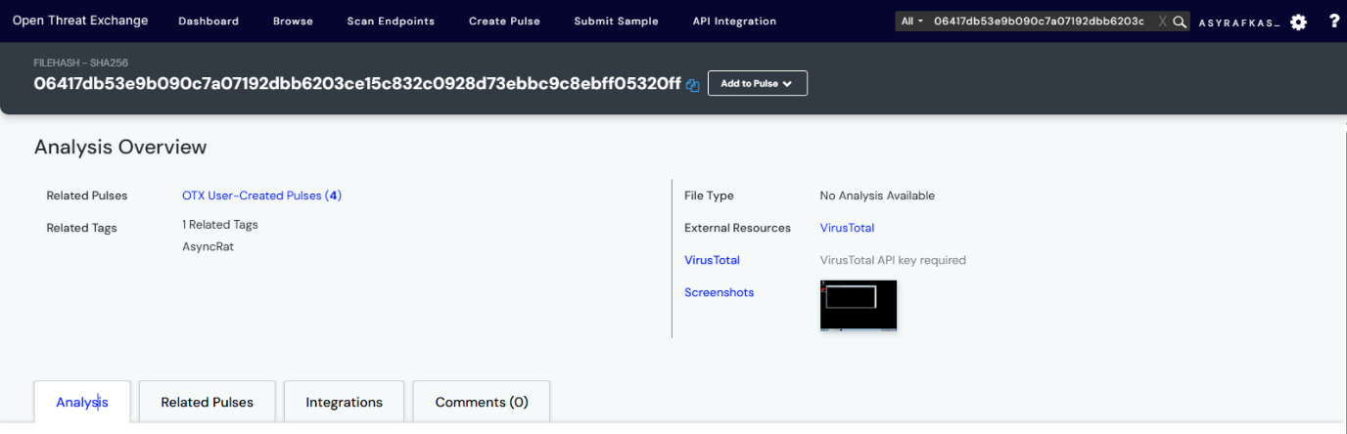
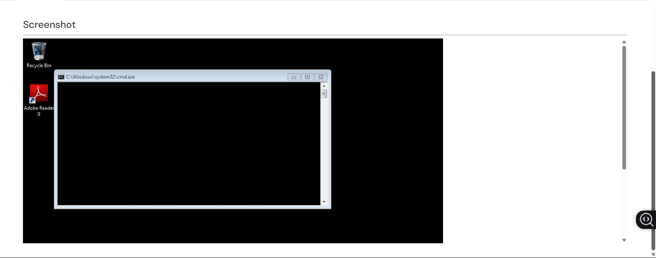
Figure 2. AlienVault OTX analysis of the suspicious file hash.

2.2 Malware Family, Category and Function
Based on the threat-intelligence results, the file was identified as AsyncRAT.
- Malware family: AsyncRAT
- Malware category: Remote Access Trojan (RAT)
- Main purpose: To allow an attacker to remotely access and control a compromised computer.
The significance of this finding is that the remote access Trojan is capable of communicating with the attacker, enabling the attacker to control the system. The findings based on file hashes are to be matched against the networking data from the workstation.
2.3 Artifact 2 – Network Indicator
Destination IP: 193.32.232.64
Destination Port: 7777
This IP address was researched by using passive threat intelligence resources. The goal was to see if this address had any links with malware, C2 activities, suspicious infrastructure, or prior threat intelligence reports.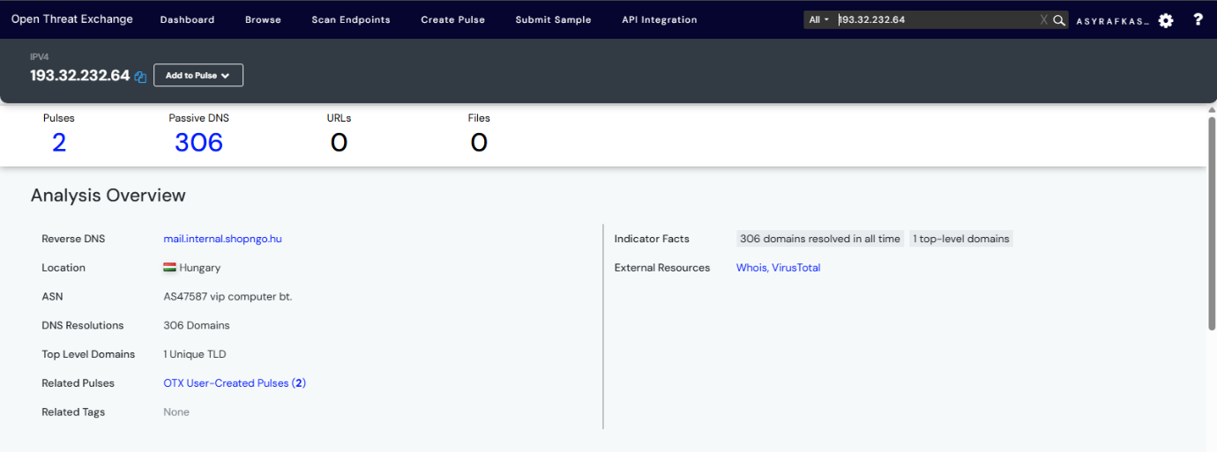
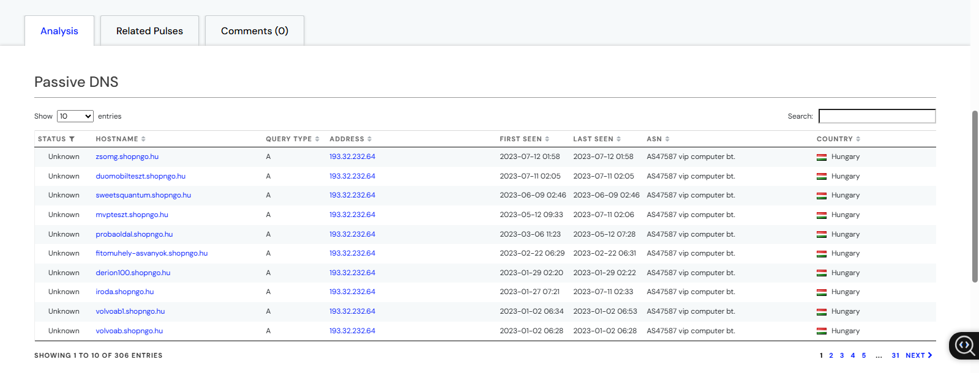
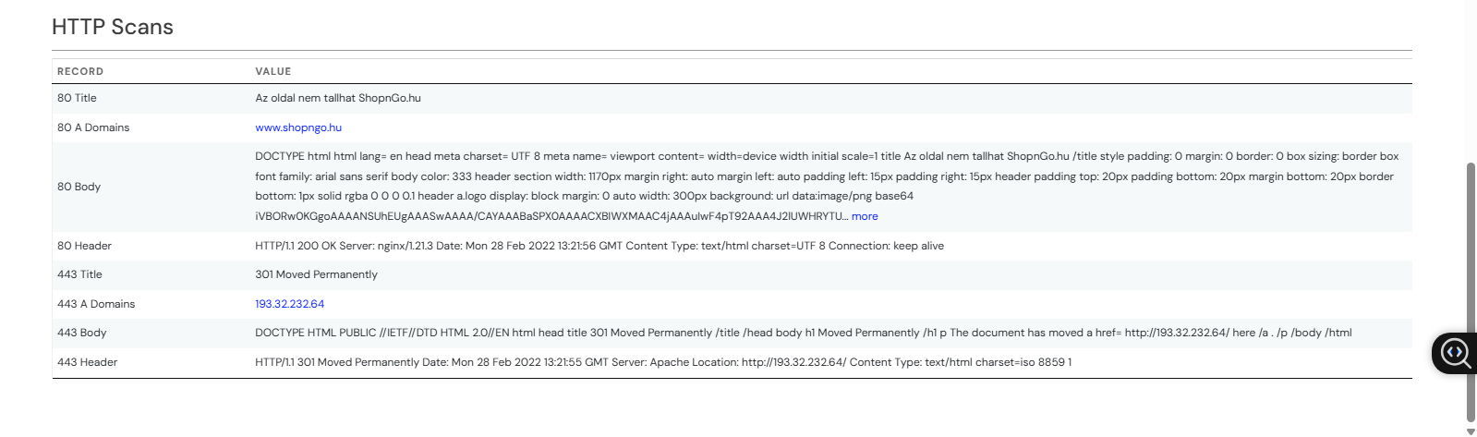
Figure 3. AlienVault OTX investigation of 193.32.232.64.
This link is significant because it happened soon after the suspicious executable file had been run. The proximity of the event to the malware execution indicates a potential link between the two.
2.4 Hash and IP Correlation
It looks like the file hash and IP address are associated with the same event. The suspicious file was opened on the computer, after which a connection to 193.32.232.64:7777 was made. The Threat Intelligence search results offer more proof of this connection.
Suspicious file → SHA-256 → AsyncRAT → 193.32.232.64:7777 → Outbound connection

3.0 PART B: WINDOWS ARTIFACT AND MALWARE BEHAVIOUR ANALYSIS
3.1 Registry Persistence
Registry Key:
HKEY_CURRENT_USER\SOFTWARE\Microsoft\Windows\CurrentVersion\Run
The Windows' Run key enables automatic running of applications as soon as the user logs into his/her account. Malware authors may take advantage of this functionality for their malware to persist on the infected machine. The Run key in question refers to a suspicious file located within the user's Temp folder, which means that the malware was meant to run upon startup or restart.

3.2 Persistence Value Analysis
Run-key value:
aha = C:\Users\admin\AppData\Local\Temp\aha.exe
The reason why this entry raises suspicion is because aha.exe is an example of a generic program name found in the Temp folder. The Temp folder is not supposed to have applications that run every time Windows starts up.
The presence of the Temp folder application and run key entry suggests that there might be a presence of malicious software on the system. The removal of the application alone is not enough since there may be a registry entry.
3.3 Process Execution
Process chain:
explorer.exe → suspicious executable → cmd.exe → temporary .bat file
The process chain reveals that the suspect executable launched cmd.exe and made use of a temporary batch file. This is important because cmd.exe can run system commands, modifying files/settings, and spawning additional processes.
In this regard, it would be worthwhile to check process creation logs, command line arguments, Windows event logs, Sysmon/EDR logs, PowerShell usage, and Temp file creation.
3.4 Network Behaviour
Connection:
193.32.232.64:7777
The outbound connection is also considered as being suspicious since it occurred almost immediately after the execution of the malicious code. The IP address and port number need to be correlated with the output of the threat intelligence obtained during part A.
The correlation can reveal whether or not the IP address belongs to the malware or attacker’s controlled infrastructure.

3.5 Malware Behaviour Correlation
User Execution → Malware Execution → Persistence → Command Execution → C2
Email attachment → suspicious executable → Run key/aha.exe → cmd.exe/.bat → 193.32.232.64:7777
Employee receives email
↓
Opens malicious executable
↓
Malware executes
↓
Registry persistence created
aha.exe → Run Key
↓
cmd.exe executes
temporary .bat file
↓
Outbound connection
193.32.232.64:7777
↓
Possible C2 communication
Figure 4. Incident attack flow.

4.0 PART C: INCIDENT CONTAINMENT, ERADICATION AND THREAT HUNTING
4.1 Endpoint Containment
The SOC must isolate the workstation and conduct investigations on it before giving the workstation back to the end user. An antivirus scan will not suffice because there have been indications of malware execution, persistence, command execution, and C2 communications on the system.The endpoint must remain isolated while conducting investigations and gathering evidence. After completion of the investigation, the endpoint must be reimaged or restored from a clean backup.
4.2 Network Containment
It is necessary to prevent any more communication between that host and the IP address 193.32.232.64:7777 via a corresponding firewall/IDS/IPS/EDR or other security gateway. This indication should be verified as malicious in order not to affect any legitimate services. Additionally, network log analysis is required in order to find out whether there was any more communication from/to the same IP address/port.
4.3 Persistence Removal
Evidence preservation is critical before anything is removed by the DFIR team. The Run-key entry, aha.exe, the processes related to it, the files created, and all other potential persistence methods should be the primary targets of the investigation.Once the evidence has been collected, then the malicious Registry entry and the malware can be deleted. It is not enough to delete aha.exe because the Run-key entry may still be there.

4.4 Threat Hunting
To check if other endpoints in the organization are infected, the SOC should perform threat hunting across the network using the known Indicators of Compromise (IOCs). I would search for
File Path: Search endpoint logs for any files running from the path C:\Users\*\AppData\Local\Temp\aha.exe.
IP Address & Destination Port: Query firewall and proxy logs for any internal IP addresses connecting to 193.32.232.64 on port 7777.
SHA-256 Hash: Use endpoint detection and response (EDR) tools to scan all hard drives for the hash 06417db53e9b090c7a07192dbb6203ce15c832c0928d73ebbc9c8ebff05320ff.

4.5 Prioritized Incident Response Recommendation
- Immediate Actions – Isolate the workstation, secure the evidence, and document all the confirmed IOCs.
- Containment – Stop any malicious communication that has been confirmed and determine whether there are other compromised endpoints.
- Eradication Get rid of malware and its persistence mechanism after documenting any necessary evidence. Re-image the workstation if necessary.
- Recovery – Recover the workstation using a trustworthy source and install the necessary security updates.
- Post-Incident Monitoring- Continue to monitor the hash, IP address, port number, Run key, aha.exe, as well as any malicious activity involving cmd.exe or batch file.
This strategy concentrates on halting the attacker initially, eradicating the malware, and ensuring the workstation’s security before restoring the network access.

5.0 CONCLUSION
CONCLUSION
There were found some signs of possible malware infection on behalf of the suspicious executable file, Run key persistence, cmd.exe and batch file execution, and the connection initiated to 193.32.232.64:7777. As one may see, there exists clear correlation between malware infection, persistence, and possible command and control communication revealed by threat intelligence from Part A and Windows artifacts from Part B. It is advised to keep the infected computer offline until the end of the investigation procedure and collection of all required evidence. After this, the computer should be brought to its trustworthy condition and returned to normal work. Moreover, it is advised to block malicious infrastructure and look for other possible endpoints using received indicators of compromise (IOCs).
REFERENCES
VirusTotal. (n.d.). VirusTotal malware and threat intelligence platform.
AlienVault Open Threat Exchange. (n.d.). AlienVault OTX threat intelligence platform.

